**Supplementary Material**

Here we will present the results for registration of 31 SHG and BF image pair, with and without applying the segmentation preprocessing step as it has been described in our proposed method.

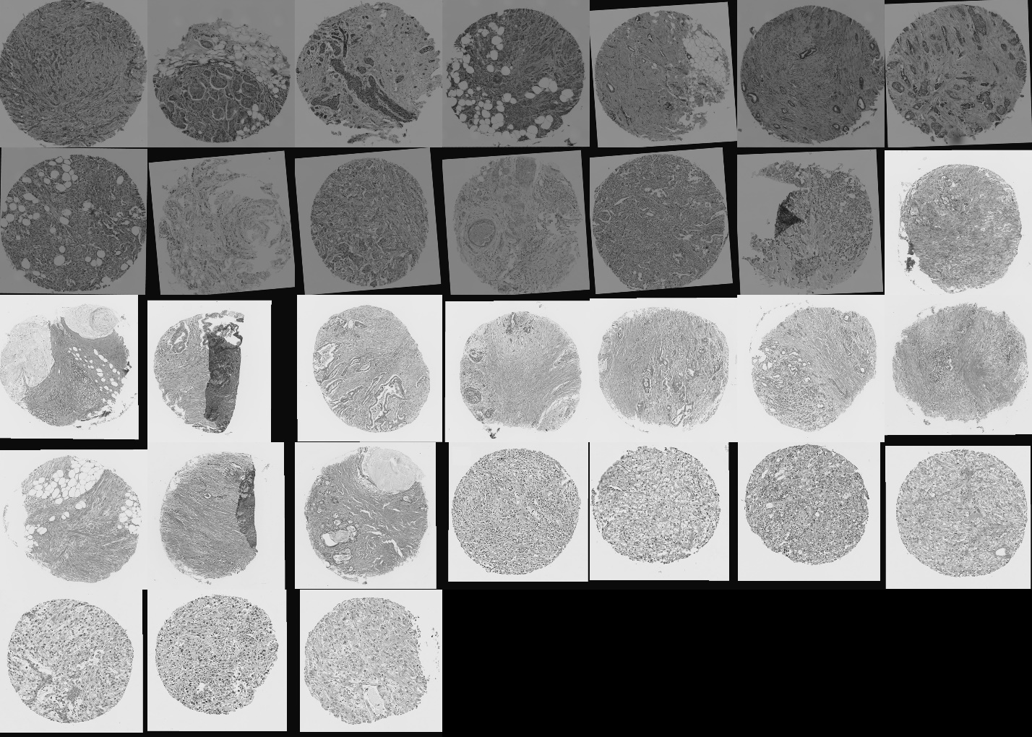

Figure 1 SimpleElastix registration results on 31 pairs of BF and SHG images directly applied to them without preprocesseing.

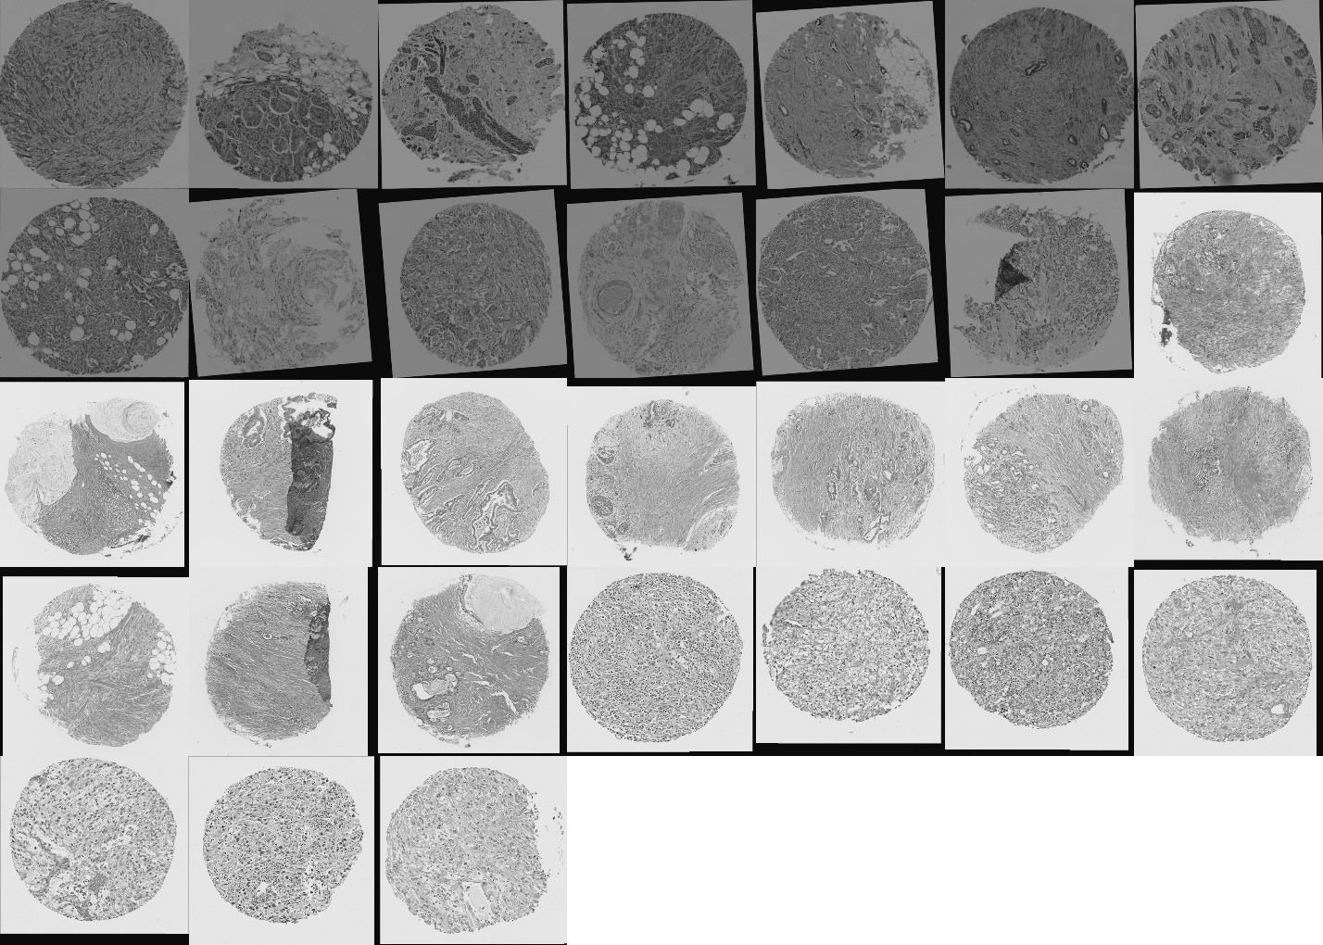

Figure 2 SimpleElastix registration results on 31 pairs of BF and SHG images applied to SHG images and extracted ECM images from BF images

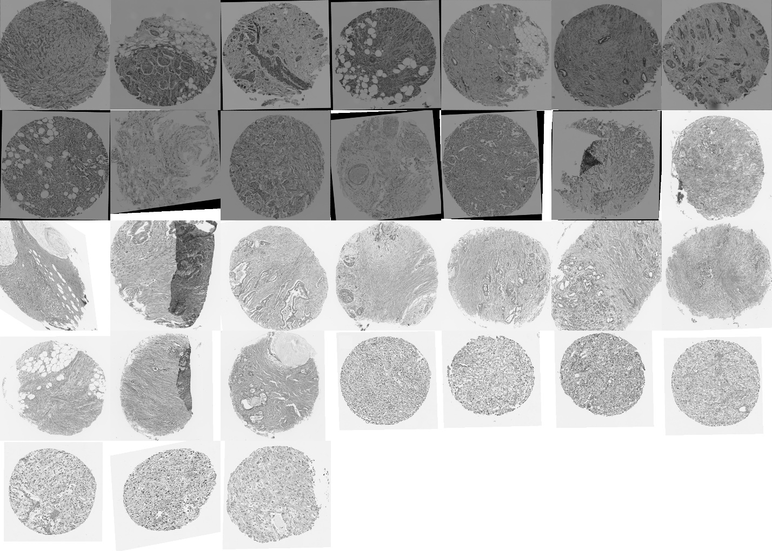

Figure 3 Proposed method registration results on 31 pairs of BF and SHG images.



Figure 4 SPO-SIFT-RANSAC registration results on 31 pairs of BF and SHG images directly applied to them without preprocesseing.

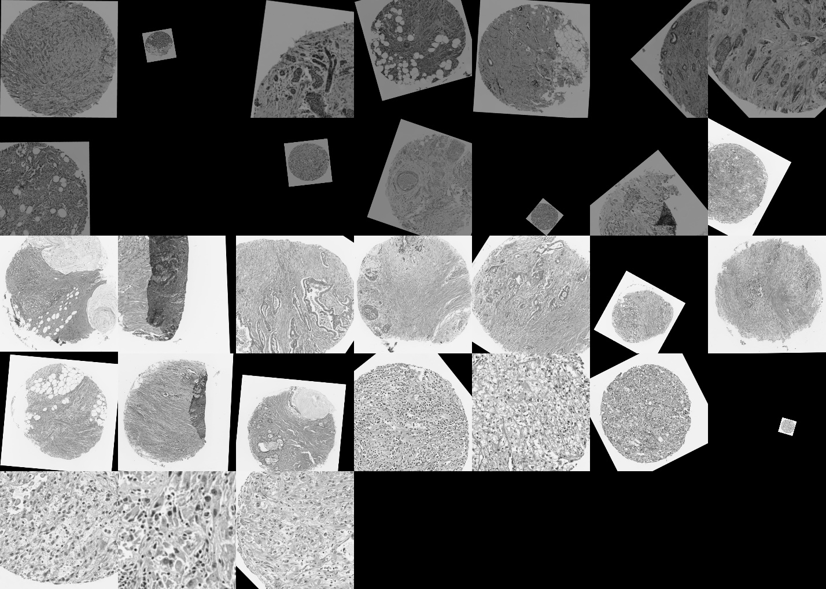

Figure 5 PSO-SIFT_RANSAC registration results on 31 pairs of BF and SHG images directly applied to SHG and extracted ECM images from BF images.



Figure 6 SIFT-RANSAC registration results on 31 pairs of BF and SHG images directly applied to them without preprocesseing.



Figure 7 SIFT_RANSAC registration results on 31 pairs of BF and SHG images directly applied to SHG and extracted ECM images from BE images.

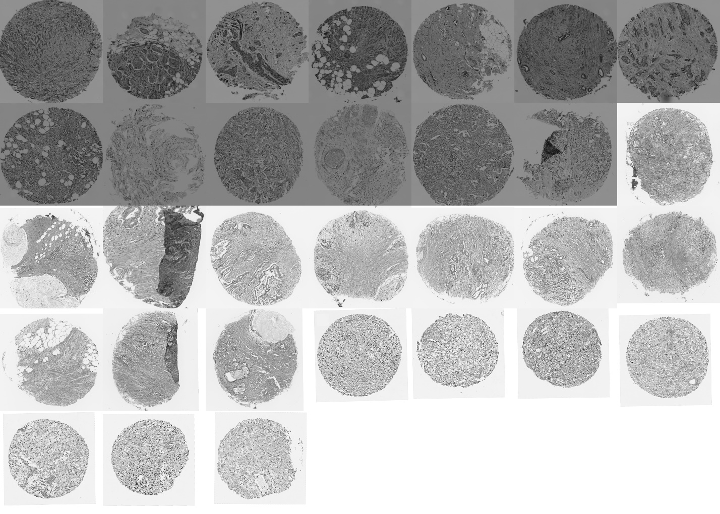

Figure 8 Ground truth manually registered images